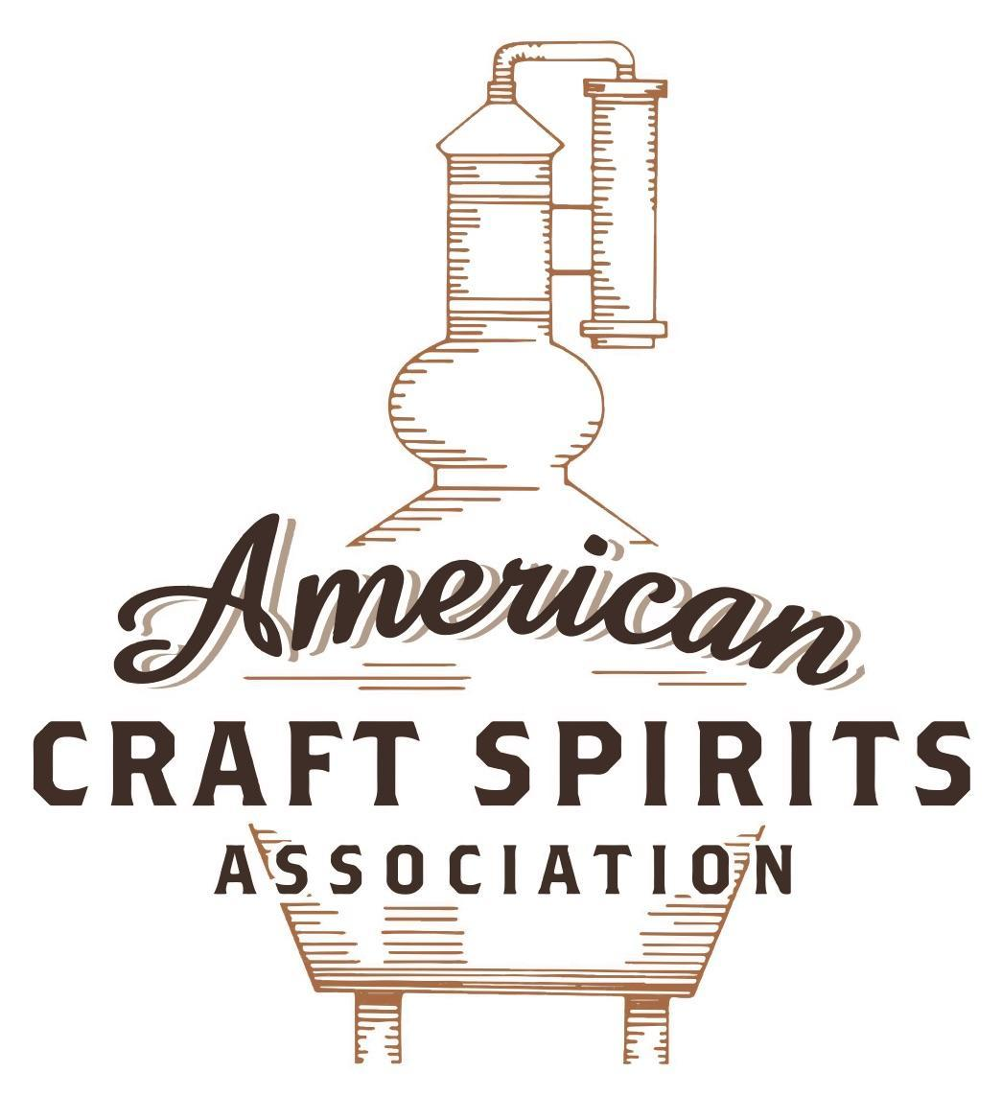
Spirits DtC Shipping Guide

This guide summarizes the direct-to-consumer shipping rules for distilleries in all 50 states and D.C. and also addresses the measures state governments have taken to ease delivery and shipping restrictions during the COVID-19 pandemic.

DtC Quick Guide Comparison

Out-of-State Distilleries  Can Ship Into State? |  |  |  | In-State Distilleries  Can Ship Within State?
State | Yes | No |  | State | Yes | No
AL |  | X |  | AL |  | X
AK | X |  |  | AK | X
AZ | X |  |  | AZ | X
AR |  | X |  | AR |  | X
CA |  | X* |  | CA |  | X*
CO |  | X |  | CO |  | X
CT |  | X* |  | CT |  | X
DE |  | X |  | DE |  | X
DC | X |  |  | DC | X
FL |  | X |  | FL |  | X
GA |  | X |  | GA |  | X
HI |  | X* |  | HI |  | ?*
ID |  | X |  | ID |  | X
IL |  | X* |  | IL |  | X*
IN |  | X |  | IN |  | X
IA |  | X* |  | IA |  | X*
KS |  | X |  | KS |  | X
KY | X |  |  | KY | X
LA |  | X |  | LA |  | X
ME |  | X* |  | ME |  | X*
MD |  | X |  | MD |  | X
MA |  | X |  | MA |  | X
MI |  | X |  | MI |  | X
MN |  | X |  | MN |  | X
MS |  | X |  | MS |  | X
MO |  | X |  | MO |  | X
MT |  | X |  | MT |  | X
NE | X |  |  | NE | X
NV |  | X* |  | NV |  | X
NH | X |  |  | NH |  | X*
NJ |  | X* |  | NJ |  | X*
NM |  | X |  | NM |  | X
NY |  | X* |  | NY |  | X*
NC |  | X |  | NC |  | X
ND | X |  |  | ND | X
OH |  | X |  | OH |  | X
OK |  | X |  | OK |  | X
OR |  | X |  | OR | X
PA |  | X* |  | PA |  | X
RI |  | X* |  | RI |  | X
SC |  | X |  | SC |  | X
SD |  | X |  | SD |  | X
TN |  | X |  | TN |  | X
TX |  | X |  | TX |  | X
UT |  | X |  | UT |  | X
VT |  | X |  | VT |  | X
VA |  | X |  | VA |  | X
WA |  | X* |  | WA | X
WV |  | X* |  | WV |  | X*

WI |  | X |  | WI |  | X
WY |  | X |  | WY |  | X

Notes:
*CA: If passed and signed into law, Senate Bill 620 would allow licensed distilled spirits producers in states other than California and licensed distilled spirits manufacturers or craft distillers in California who obtain distilled spirits direct shipper permits to ship directly to consumers in California
*CT: Consumers with appropriate permit may receive alcohol shipments
*HI: Consumers with appropriate permit may receive alcohol shipments; If passed and signed into law, Senate Bill 65 would allow licensed distilled spirits manufacturers in Hawaii and in states other than Hawaii who obtain direct shipper permits to ship directly to consumers in Hawaii
*IL: If passed and signed into law, Senate Bill 0532 would allow licensed distilled spirits producers in Illinois and in states other than Illinois who obtain distillery shippers’ licenses to ship directly to consumers in Illinois
*IA: If passed and signed into law, House File 639 would allow native distilled spirits manufacturers in Iowa and in states other than Iowa who obtain direct shipper permits to ship directly to consumers in Iowa and to consumers in states other than Iowa
*ME: If passed and signed into law, Legislative Document 1358 would allow distilleries outside of Maine with current manufacturer licenses and distilleries licensed in Maine who obtain spirits direct shipper licenses to ship directly to consumers in Maine
*NJ: (1) If passed and signed into law, Assembly Bill 3167 would allow a craft distillery licensees to ship no more than 9 liters of distilled spirits to a consumer in New Jersey; (2) If passed and signed into law, Senate Bill 3020 would allow craft distillery licensees in New Jersey or in states other than New Jersey to ship no more than 20 liters of distilled spirits to a consumer in New Jersey via common carrier
*NV: Licensed individuals can import one gallon per month of spirits for personal use and the out-of-state supplier must pay excise tax
*NH: If passed and signed into law, Senate Bill 125 would allow licensed liquor manufacturers who obtain direct to consumer shipping permits from the commission to ship directly to consumers in New Hampshire
*NY: Consumer may import up to 90L of liquor per year for personal use without a license; If passed and signed into law, Assembly Bill 3275 would allow licensed liquor manufacturers in states other than New York and licensed distillers and farm distillers in New York to ship no more than thirty-six cases (no more than nine liters per case) of liquor to consumers in New York
*PA: Consumer may place a special liquor order and distiller must ship to a PLCB-operated store
*RI: Distiller can only ship to customer if order was personally placed by customer at distiller's premises
*WA: If passed and signed into law, House Bill 1432 would allow licensed spirits manufacturers in states other than Washington to ship spirits to consumers in Washington
*WV: Distilleries, mini-distilleries, or micro-distilleries licensed in West Virginia or a state other than West Virginia who obtain private direct shipper licenses to ship to a consumer in West Virginia, however the shipments must be made to a retail liquor outlet

FLORIDA
Shipment Outbound – No (Fla. Stat. § 565.03(2)(c)(4)).
Shipment Inbound – No (Fla. Stat. § 561.545(1)).
Shipment Intra-state – No, craft distillers can only sell in face-to-face transactions (See § 565.03(2)(c)(4)).
COVID-19 Measures – The existing renewal deadline is suspended through December 31, 2020, for manufacturers with an existing renewal deadline on or before Dec 31, 2020, unless extended by subsequent order.
Link: http://www.myfloridalicense.com/dbpr/os/documents/EO%2020-210.pdf
Citation (shipment)
Florida Statutes
Fla. Stat. § 561.545. Certain shipments of beverages prohibited; penalties; exceptions.
The Legislature finds that the direct shipment of alcoholic beverages by persons in the business of selling alcoholic beverages to residents of this state in violation of the Beverage Law poses a serious threat to the public health, safety, and welfare; to state revenue collections; and to the economy of the state. The Legislature further finds that the penalties for illegal direct shipment of alcoholic beverages to residents of this state should be made adequate to ensure compliance with the Beverage Law and that the measures provided for in this section are fully consistent with the powers conferred upon the state by the Twenty-first Amendment to the United States Constitution.
(1) Any person in the business of selling alcoholic beverages who knowingly and intentionally ships, or causes to be shipped, any alcoholic beverage from an out-of-state location directly to any person in this state who does not hold a valid manufacturer’s or wholesaler’s license or exporter’s registration issued by the Division of Alcoholic Beverages and Tobacco or who is not a state-bonded warehouse is in violation of this section.
Link: http://www.leg.state.fl.us/statutes/index.cfm?App_mode=Display_Statute&Search_String=&URL=0500-0599/0561/Sections/0561.545.html
Fla. Stat. § 565.03. License fees; manufacturers, distributors, brokers, sales agents, and importers of alcoholic beverages; vendor licenses and fees; distilleries and craft distilleries.
(2)(c) A craft distillery licensed under this section may sell to consumers, at its souvenir gift shop, branded products distilled on its premises in this state in factory-sealed containers that are filled at the distillery for off-premises consumption. Such sales are authorized only on private property contiguous to the licensed distillery premises in this state and included on the sketch or diagram defining the licensed premises submitted with the distillery’s license application. All sketch or diagram revisions by the distillery shall require the division’s approval verifying that the souvenir gift shop location operated by the licensed distillery is owned or leased by the distillery and on property contiguous to the distillery’s production building in this state.
1. A craft distillery may not sell any factory-sealed individual containers of spirits except in face-to-face sales transactions with consumers who are making a purchase of no more than six individual containers of each branded product.
2. Each container sold in face-to-face transactions with consumers must comply with the container limits in s. 565.10, per calendar year for the consumer’s personal use and not for resale and who are present at the distillery’s licensed premises in this state.
3. A craft distillery must report to the division within 5 days after it reaches the production limitations provided in paragraph (1)(b). Any retail sales to consumers at the craft distillery’s licensed premises are prohibited beginning the day after it reaches the production limitation.
4. A craft distillery may not ship or arrange to ship any of its distilled spirits to consumers and may sell and deliver only to consumers within the state in a face-to-face transaction at the distillery property. However, a craft distiller licensed under this section may ship, arrange to ship, or deliver such spirits to manufacturers of distilled spirits, wholesale distributors of distilled spirits, state or federal bonded warehouses, and exporters.
Link:
http://www.leg.state.fl.us/Statutes/index.cfm?App_mode=Display_Statute&Search_String=&URL=0500-0599/0565/Sections/0565.03.html

The American Craft Spirits Association (ACSA) is working diligently to give our members and industry partners relevant, current updates on statutes and regulations impacting production, sale and distribution of spirits. With the declaration of the novel coronavirus (COVID-19) in early 2020, many states have issued temporary policy changes or longer-term modernization of alcohol beverage laws. State statutes, regulations created by the state alcohol regulatory authority, as well as any other relevant guidance provided by such authorities (such as advisories, opinions, bulletins, etc.) were reviewed in creation of this document. No city or county ordinances were reviewed. Distillers should be aware that even in states where direct shipping is permissible, always remember to avoid shipping to dry counties. Please consult with your state guild or alcohol beverage authority for the most up-to-date information. This content is intended for educational and informational purposes only. ACSA's pro bono law firm of Malkin Law P.A. provided the core content found in this comprehensive overview of the spirits distribution after COVID-19. It was completed in August 2021 and will be updated regularly. If you have updates you would like to provide, please send to legislation@americancraftspirits.org or directly to the law firm at: ryan@malkin.law / malkin.law. Thank you.

